FitTrack AI - Full Stack Fitness Tracking and AI Recommendation System
The FitTrack AI project is a full-stack fitness tracking application combining a React frontend, a secure Node.js and Express.js REST backend, MongoDB Atlas persistence, JWT authentication, workout management, dashboard analytics, and Google Gemini AI integration.
This document follows the supplied FitTrack AI reference document's organization, typography, spacing, and presentation style while documenting the upgraded implementation. It replaces the earlier Postman-oriented testing flow with Thunder Client and documents the React client, dashboard, profile management, pagination, filtering, and current Atlas configuration.
Marked screenshot spaces are included throughout this document. Each placeholder specifies the exact screen or result that should be captured and inserted later.
Figure 1: Project overview / VS Code root
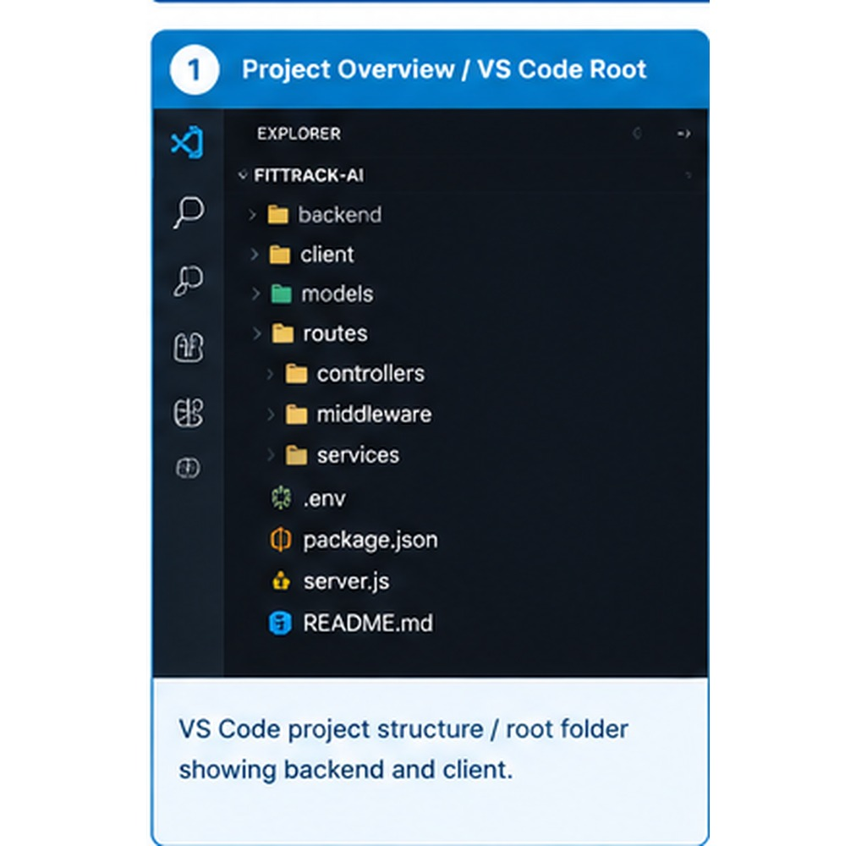

Description
The FitTrack AI backend is a secure, modular, and AI-enabled RESTful application developed to simplify workout tracking and provide intelligent fitness guidance. The backend uses Node.js, Express.js, MongoDB, Mongoose, JWT, bcryptjs, and the Google GenAI SDK.
The upgraded project adds a React client so the REST API can be consumed through a web interface. The backend remains responsible for authentication, workout CRUD operations, searching, dashboard analytics, profile management, validation, authorization, and AI service invocation.
MongoDB Atlas is used as the persistent database. Protected endpoints require a valid JWT token, and passwords are hashed using bcryptjs before storage.
Figure 2: Running application
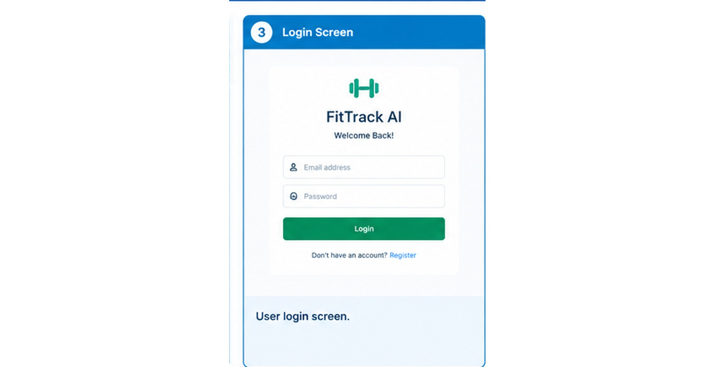
Login screen
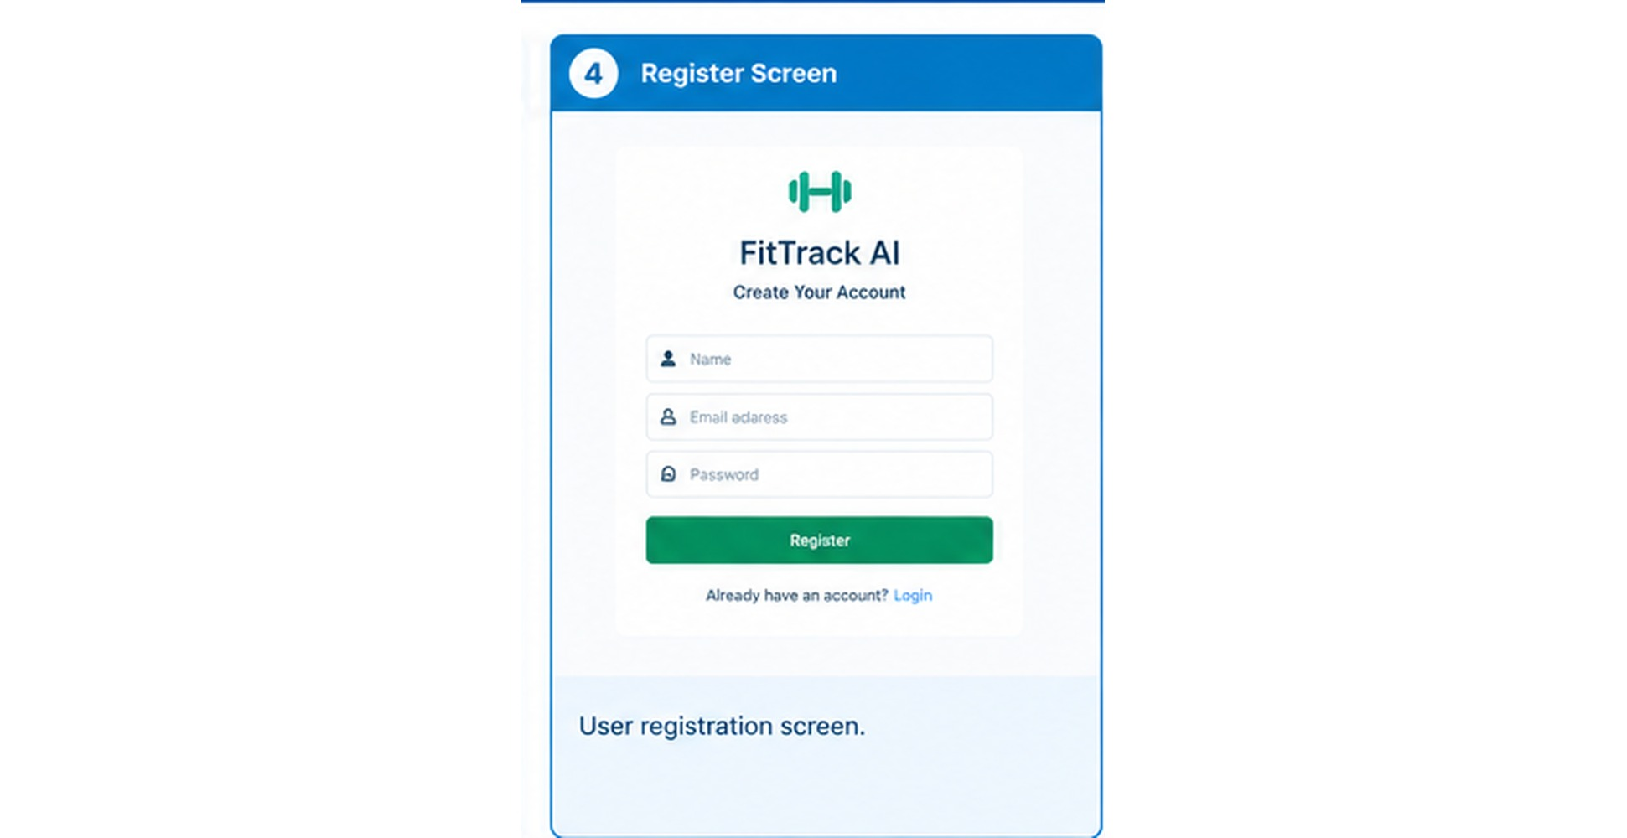
Register screen

Scenario-Based Case Study

Background
A fitness user wants one application for recording workouts, reviewing progress, searching workout history, and obtaining personalized recommendations. Manual notebooks or spreadsheets make it difficult to maintain a consistent history and calculate useful statistics.

Problem
● Difficulty maintaining a centralized workout history.
● Manual tracking can make historical review slow and inconsistent.
● Personal workout information requires authenticated access.
● Users need search, category filtering, and date filtering.
● Users need a dashboard to summarize workout activity.
● Users may want personalized AI guidance based on fitness information.

Solution
FitTrack AI centralizes workout data behind authenticated REST APIs and presents it through a React interface. Dashboard statistics summarize activity, while the Gemini service can generate recommendations and fitness insights when the Google AI project has generation access.

Solution and Objectives
The main objective is to provide a maintainable full-stack fitness application with clear separation between presentation, API logic, persistence, authentication, analytics, and AI services.
● Secure registration and login.
● JWT-protected profile and workout resources.
● Complete workout create, read, update, and delete operations.
● Search by workout name or category.
● Pagination and category/date filtering.
● Dashboard analytics and recent activity.
● React-based web interface.
● MongoDB Atlas storage.
● Google Gemini recommendation and insight service.
The architecture also leaves room for nutrition tracking, BMI calculation, reminders, wearable integration, and additional fitness analytics.

Usage

User Usage
A registered user creates an account using the registration endpoint and logs in using email and password. After successful authentication, the backend returns a JWT token. The token is supplied in the Authorization header for protected operations.
● Create and manage a profile.
● Create workout records.
● View paginated workout history.
● Search and filter workouts.
● Retrieve, update, and delete a workout.
● View dashboard statistics.
● Request AI workout recommendations.
● Request AI fitness insights.

AI Usage
Workout recommendations accept age, fitness goal, and experience level. Fitness insights accept total workouts, average duration, and total calories burned.
Figure 3: User workflow / dashboard
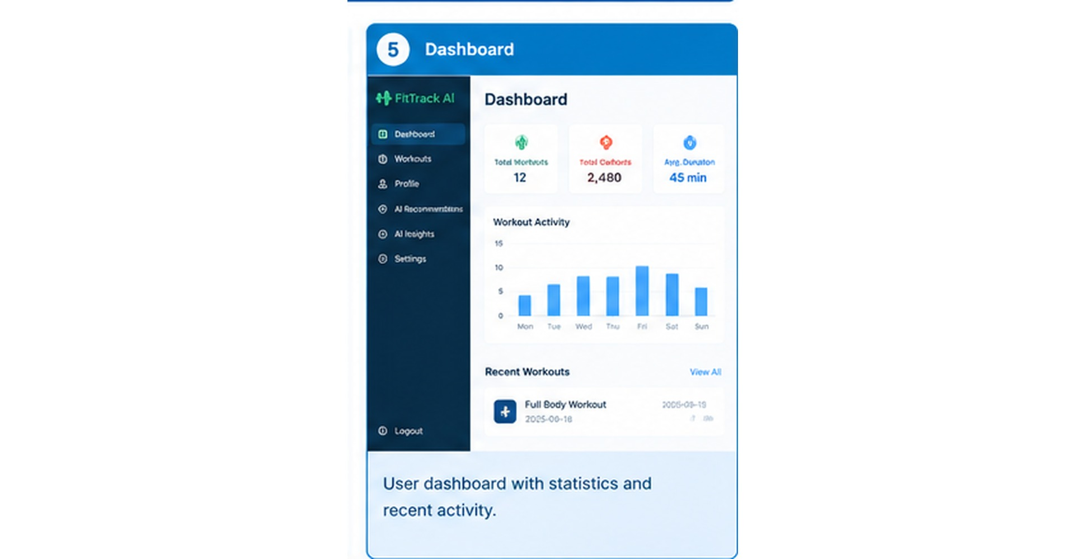

Outcome
The upgraded FitTrack AI provides a complete path from web interface to secured API to database and AI service. The React client consumes standardized JSON responses, while the Express backend keeps authentication, data access, analytics, and AI concerns separated.
The application eliminates repetitive manual workout record keeping and provides structured views of workout history and progress. The dashboard reduces the need to calculate totals manually.
The AI integration is implemented in the application. Actual AI generation depends on the Google AI project having permission to generate content for the configured model. If Gemini access is unavailable, the non-AI authentication, workout, search, and dashboard features remain independent.

1. Software Requirements
● Windows 10/11, macOS, or Linux.
● Node.js with npm.
● Visual Studio Code.
● MongoDB Atlas account and database connection string.
● Thunder Client VS Code extension.
● Google AI project and Gemini API key for AI features.
● Modern web browser.
The client and server are developed as separate npm applications. Internet access is required for MongoDB Atlas and Gemini API communication.

2. Hardware Requirements
● Processor: Intel Core i5 / AMD Ryzen 5 or equivalent.
● RAM: 8 GB minimum; 16 GB recommended for development.
● Storage: At least 2 GB free working space.
● Internet connection for Atlas and Gemini services.
Actual requirements vary depending on the number of browser tabs, development tools, and other applications running simultaneously.

Epic 1: Project Architecture
The project follows a layered architecture. React acts as the client interface, Express provides the HTTP gateway, routes map endpoints to controllers, middleware protects secured resources, services encapsulate reusable integrations, Mongoose models define persistence, and MongoDB Atlas stores application data.
Typical request flow:
React / Thunder Client → Express → Route → JWT Middleware → Controller → Model or Service → MongoDB Atlas / Gemini → JSON Response
Figure 4: Architecture diagram
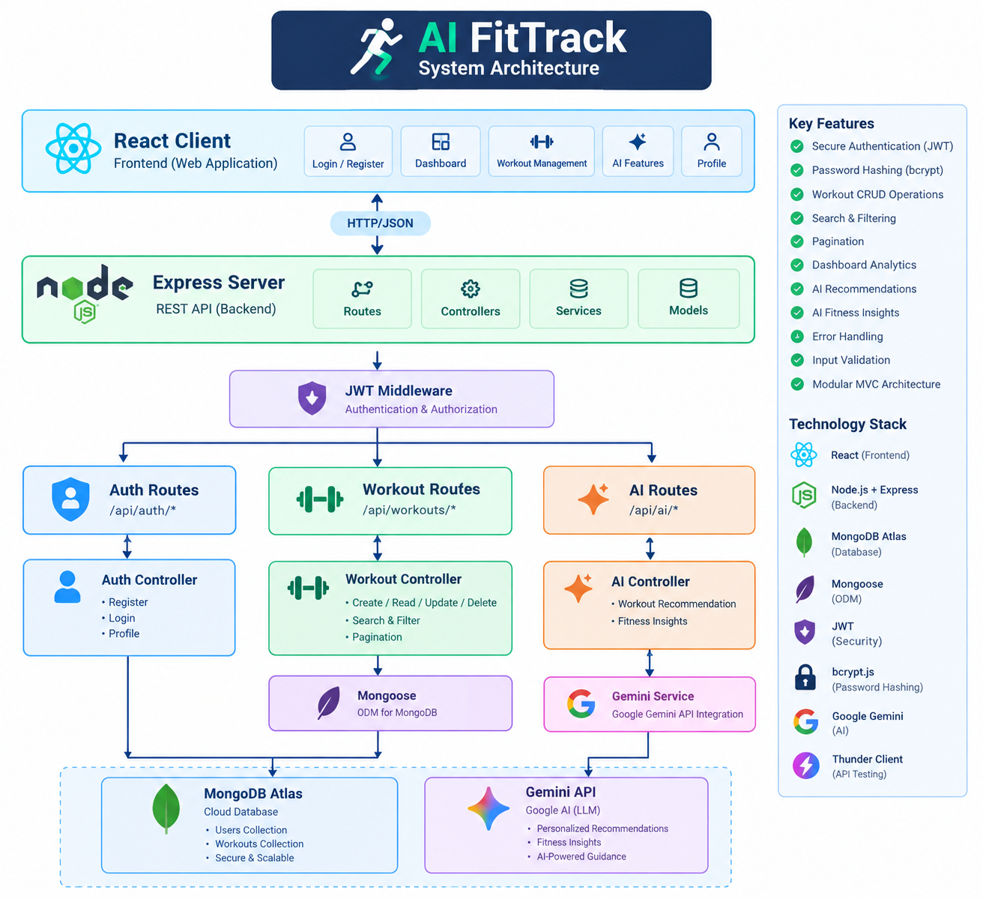
System Architecture
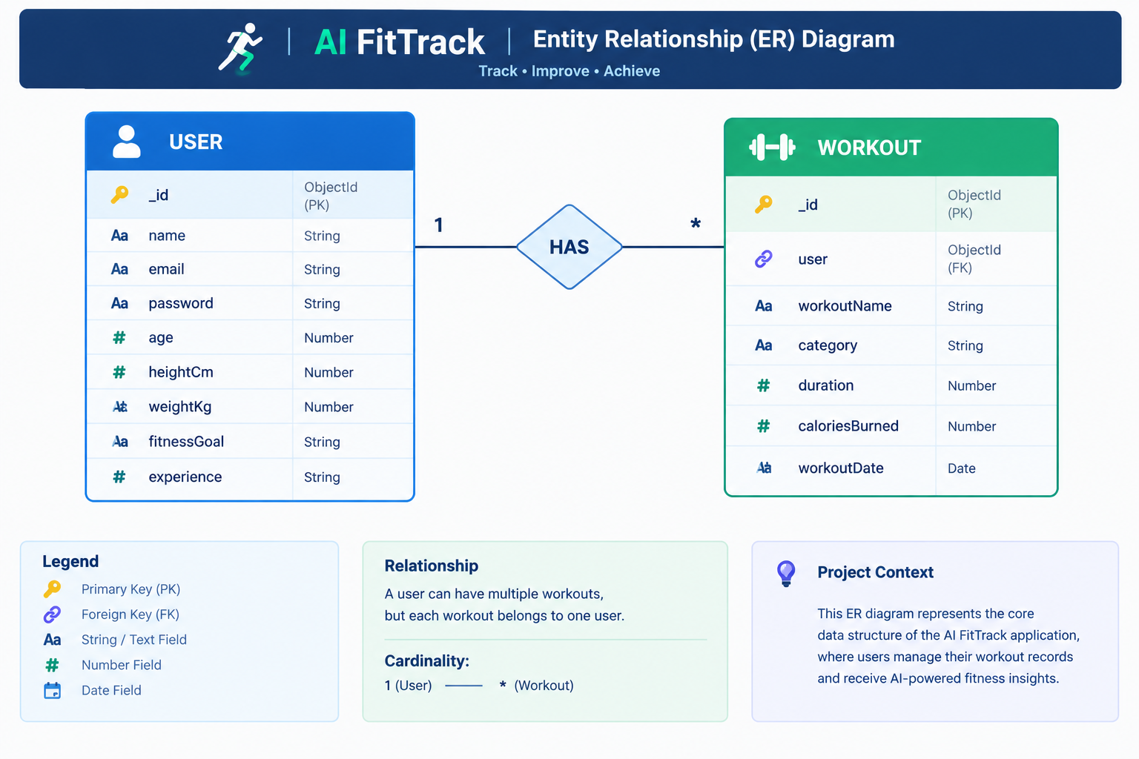
Entity Relationship (ER) Diagram

Overall Architecture Components
● React client application.
● Express.js API server.
● Authentication and error middleware.
● Authentication, workout, dashboard, and AI routes.
● Authentication, workout, dashboard, and AI controllers.
● Gemini AI service.
● Mongoose User and Workout models.
● MongoDB Atlas database.
Each layer communicates through defined inputs and outputs, reducing coupling and making individual modules easier to test and maintain.

Project Folder Structure
The upgraded project is divided into a React client and an Express server.
AI-FitTrack-React-Upgraded/
├── client/
│ ├── index.html
│ ├── package.json
│ └── src/
│ ├── lib/api.js
│ ├── main.jsx
│ └── styles.css
└── server/
├── .env
├── package.json
└── src/
├── app.js
├── server.js
├── config/db.js
├── controllers/
├── middleware/
├── models/
├── routes/
└── services/
Figure 5: VS Code Explorer

Client Layer - React Frontend
The React client is the presentation layer for the upgraded project. It communicates with the Express backend through HTTP requests and displays authentication, workout, dashboard, and AI information.
● Sends API requests.
● Displays workout information.
● Handles authenticated user flow.
● Displays dashboard analytics.
● Invokes AI recommendation and insight APIs.
● Displays success and error responses.
Figure 6: React frontend
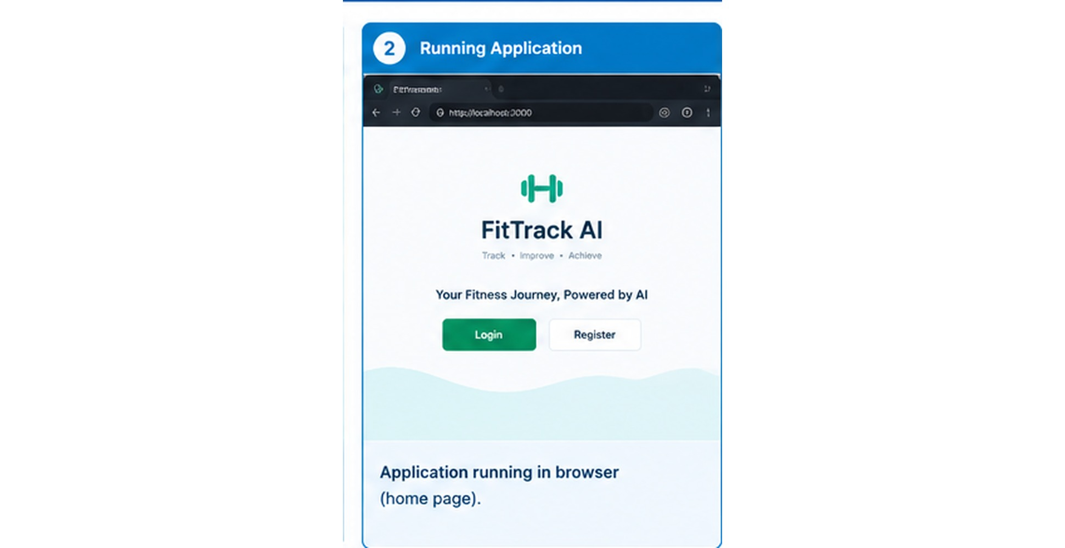

Express Server Gateway
The Express server is the central gateway. It loads environment variables, configures CORS, security headers, request logging, JSON parsing, routes, and centralized error handling.
The health endpoint is:
GET http://localhost:5000/api/health
A successful response identifies the API and enabled feature groups.

Authentication Middleware
Protected APIs use JWT authentication middleware. The middleware reads the Authorization header, extracts the bearer token, verifies the signature using JWT_SECRET, identifies the user, and attaches authenticated user information to the request.
Authorization: Bearer YOUR_JWT_TOKEN
● Prevents unauthorized access.
● Secures personal workout information.
● Allows only authenticated users to access protected resources.
● Keeps authentication logic outside individual controllers.

Route Layer
Routes define the API endpoints and map incoming HTTP requests to controller methods.
Route Group | Base Path | Purpose
Authentication | /api/auth | Registration, login, profile
Workouts | /api/workouts | Workout CRUD and search
Dashboard | /api/dashboard | Analytics and recent activity
AI | /api/ai | Recommendations and fitness insights
All routes except health, registration, and login require authentication as implemented in the server.

Controller Layer
Controllers receive validated requests from routes and coordinate database operations or service calls.
● Authentication Controller: registration, login, profile retrieval and profile update.
● Workout Controller: create, list, search, get by ID, update, delete.
● Dashboard Controller: totals, averages, streak, categories, weekly activity and recent records.
● AI Controller: validation and invocation of Gemini recommendation and insight services.

Service Layer
The service layer contains reusable logic that should not be tightly coupled to HTTP route definitions.

Gemini AI Service
● Prepares prompts.
● Sends model requests.
● Receives generated content.
● Returns formatted recommendations.
● Surfaces provider errors for controlled API handling.

Authentication Support
● bcryptjs hashes and compares passwords.
● jsonwebtoken creates and verifies JWT tokens.

Database Layer - MongoDB Atlas
MongoDB Atlas is the project's persistent NoSQL database. The connection string is supplied through MONGO_URI in the server environment file.
The main collections are Users and Workouts. Mongoose provides schema validation, relationships, timestamps, and database access methods.
The current project does not require a local MongoDB service for normal development because it connects directly to Atlas.
Figure 7: MongoDB Atlas
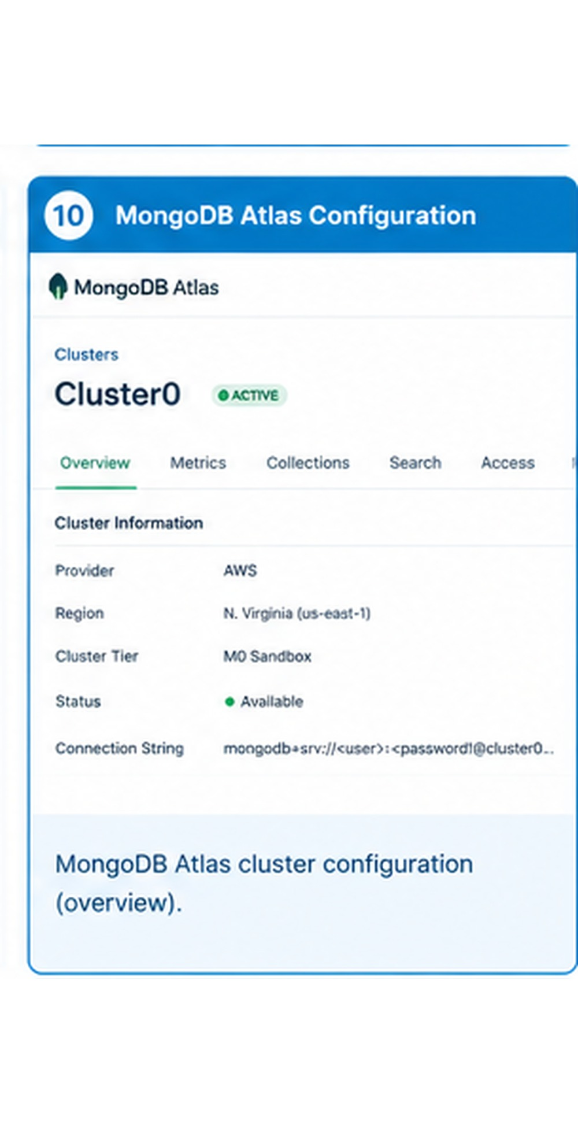
Cluster & collections
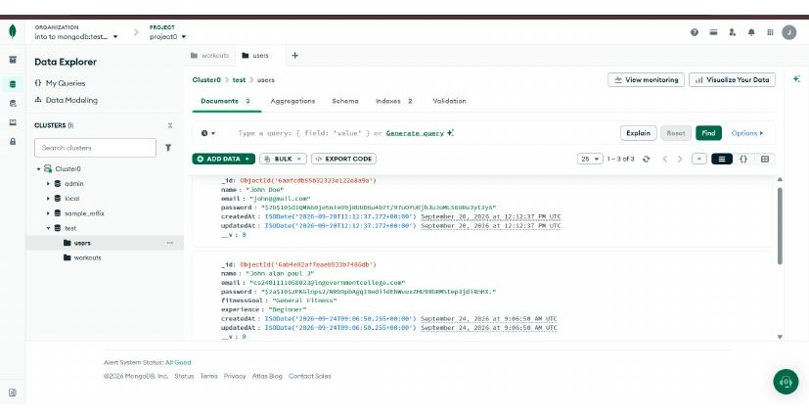
users collection
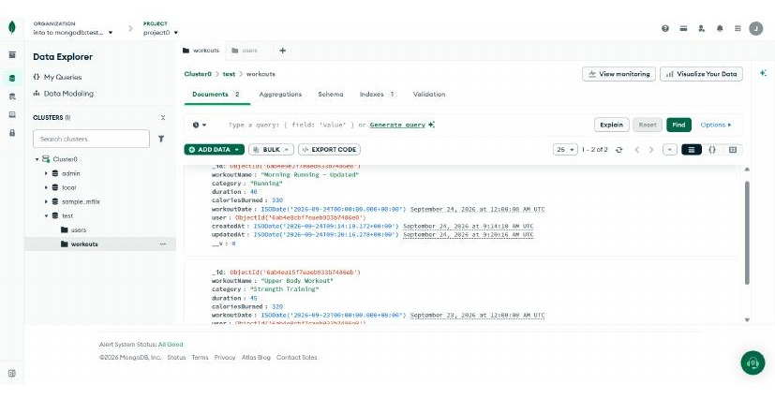
workouts collection

Entity Relationship - User
The User entity stores authentication and fitness profile information.
Field | Type | Description
_id | ObjectId | Primary key
name | String | User name
email | String | Unique email address
password | String | Bcrypt-hashed password
age | Number | Profile age
heightCm | Number | Height in centimeters
weightKg | Number | Weight in kilograms
fitnessGoal | String | Selected fitness goal
experience | String | Beginner, Intermediate, or Advanced
createdAt / updatedAt | Date | Automatic timestamps

Entity Relationship - Workout
The Workout entity stores workout information belonging to an authenticated user.
Field | Type | Description
_id | ObjectId | Primary key
user | ObjectId | Reference to User
workoutName | String | Workout name
category | String | Workout category
duration | Number | Duration in minutes
caloriesBurned | Number | Calories burned
workoutDate | Date | Workout date
createdAt / updatedAt | Date | Automatic timestamps
Relationship: one user can have many workout records, while each workout belongs to one authenticated user.

Key Features
● JWT-based registration and login.
● Bcrypt password hashing.
● Protected profile management.
● Complete workout CRUD.
● Search by workout name and category.
● Pagination and date/category filtering.
● Dashboard analytics.
● React frontend.
● Google Gemini recommendation service.
● Fitness insight generation.
● Centralized error handling.
● Standardized JSON API responses.
Figure 8: Feature dashboard
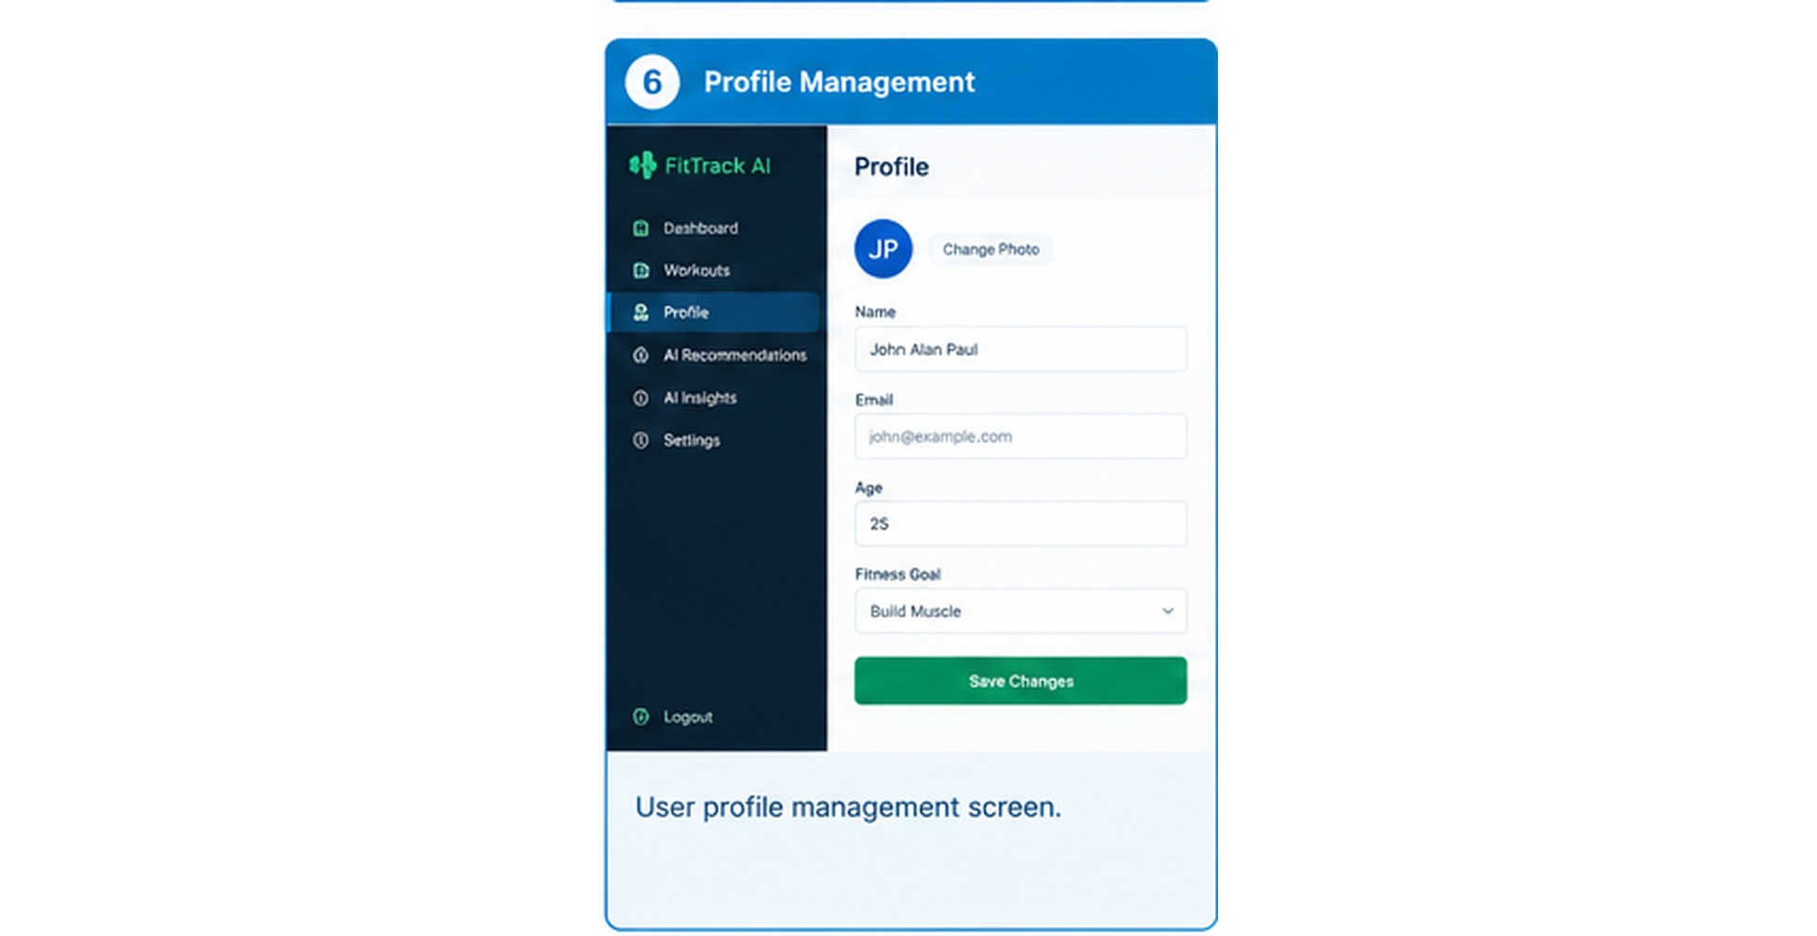
Profile
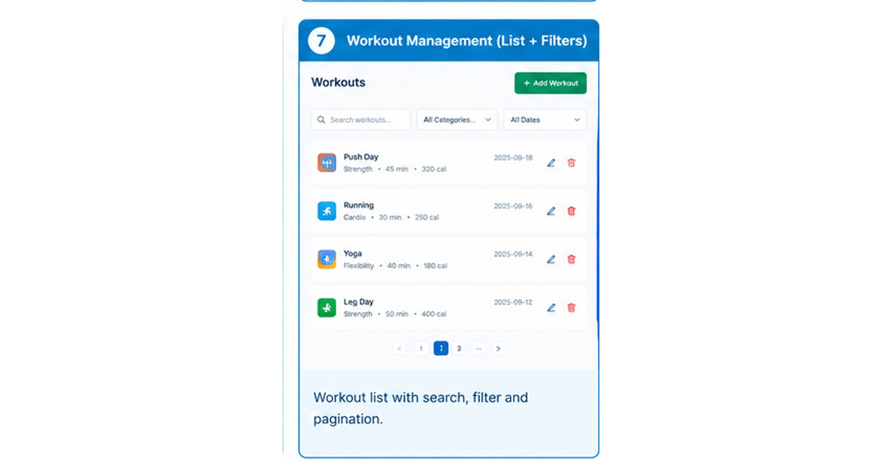
Workout history (search/edit/delete)

Secure Authentication
Registration accepts a name, email, and password. The password is hashed before storage. Login verifies credentials and returns a JWT token for protected APIs.
Profile operations allow the authenticated user to retrieve and update information such as name, age, height, weight, fitness goal, and experience.
POST /api/auth/register
{
"name": "John",
"email": "john@example.com",
"password": "12345678"
}
POST /api/auth/login
{
"email": "john@example.com",
"password": "12345678"
}
Figure 9: Register and login
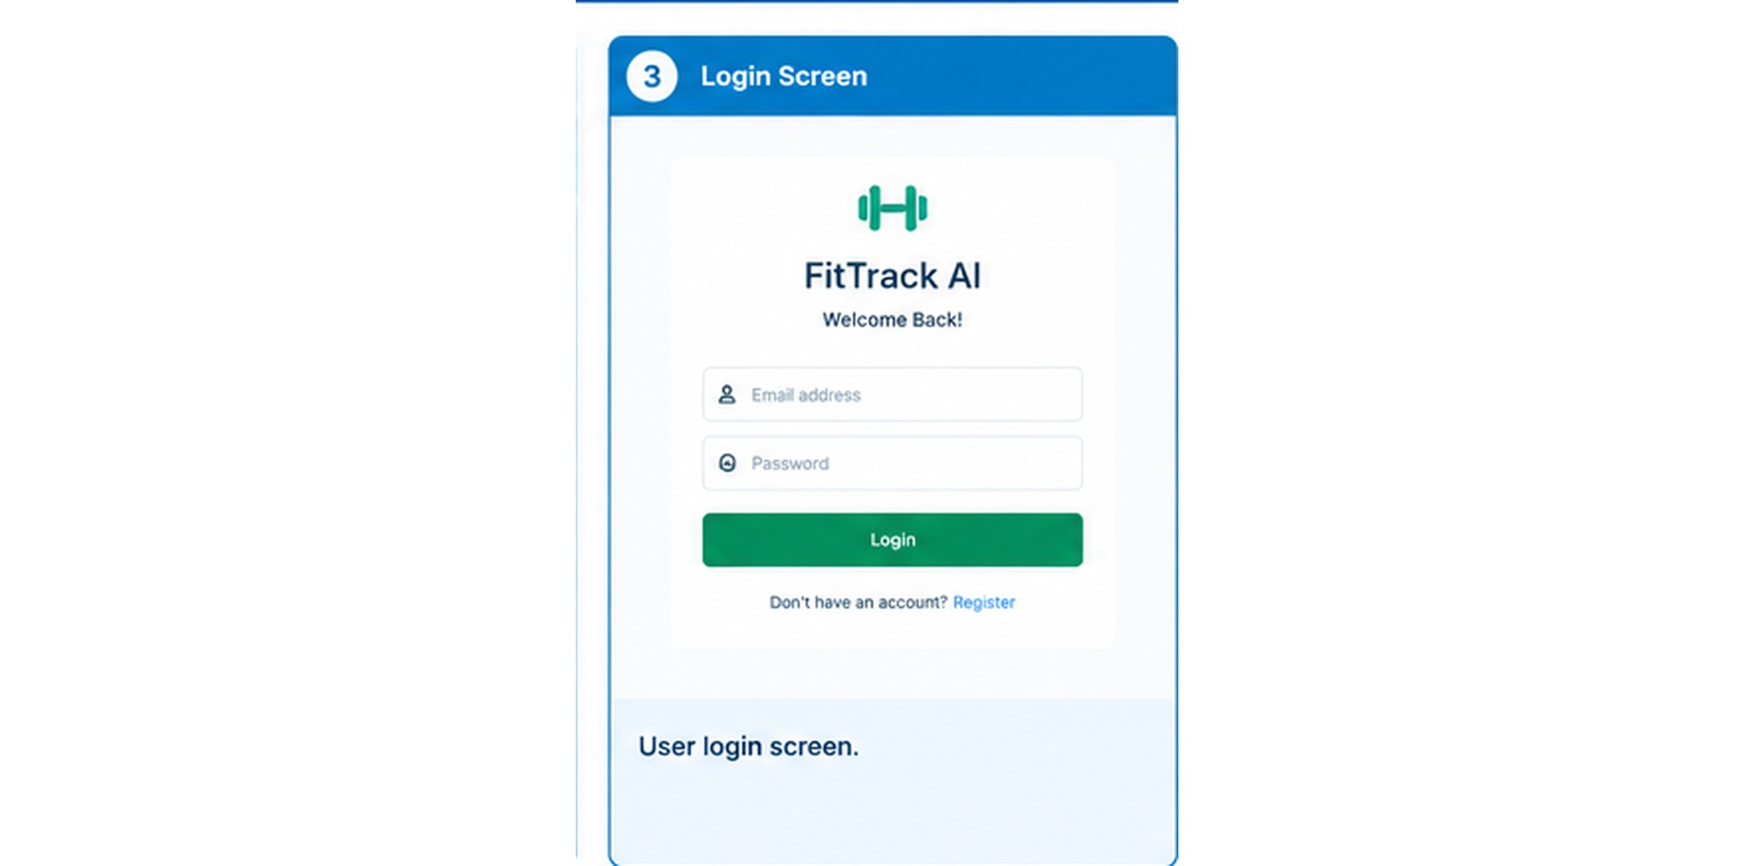

Workout Management
Workout management implements create, read, update, and delete operations. Each workout is associated with the authenticated user's ID.
POST /api/workouts
{
"workoutName": "Morning Running",
"category": "Running",
"duration": 30,
"caloriesBurned": 250,
"workoutDate": "2026-09-24"
}
● Allowed categories include Cardio, Strength Training, Yoga, Running, Cycling, and Walking.
● Duration is recorded in minutes.
● Calories burned are stored as a numeric value.
● Workout date is stored as a date value.
Figure 10: Add workout
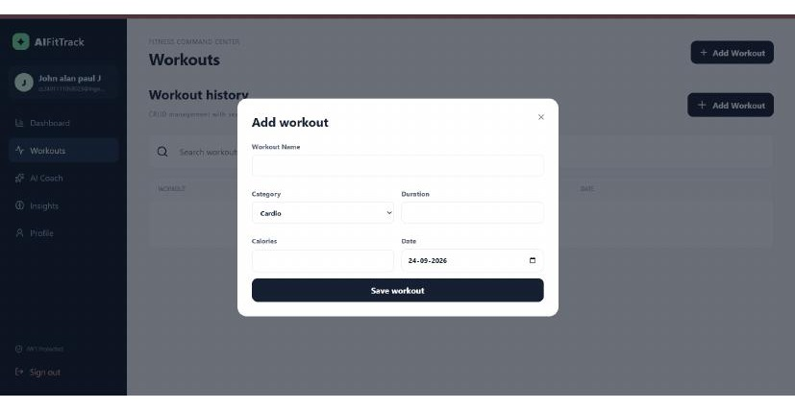
Add Workout form (UI)
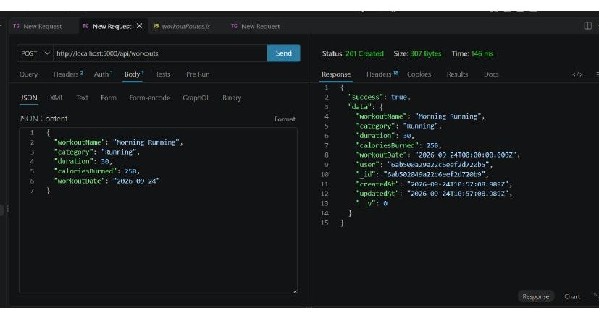
POST /api/workouts (201)

Workout Search, Pagination and Filters
The current workout list endpoint supports page, limit, category, from, to, and sort query parameters. Search is available through a dedicated search endpoint.
GET /api/workouts?page=1&limit=10
GET /api/workouts?category=Running
GET /api/workouts?from=2026-09-01&to=2026-09-24
GET /api/workouts/search?q=running
GET /api/workouts/search?q=morning&category=Running
Figure 11: Search and filter
Search filter (UI)
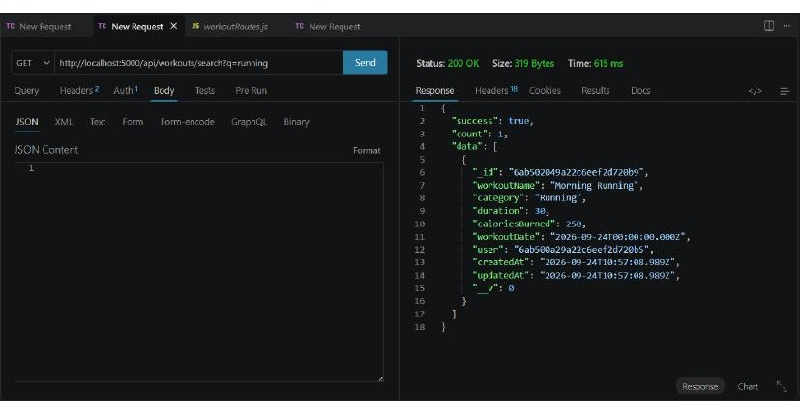
GET /api/workouts/search (200)

Dashboard Analytics
GET /api/dashboard returns an authenticated summary of workout activity.
● totalWorkouts
● totalDuration
● totalCalories
● averageDuration
● streak
● categories
● weekly activity for the recent period
● recent workout records
The dashboard reduces manual calculation and gives the React client a single endpoint for summary information.
Figure 12: Dashboard analytics

Google Gemini Integration
The project uses a dedicated Gemini service through the Google GenAI SDK. The model name is configured through GEMINI_MODEL so the provider configuration can be changed without modifying controller logic.
GEMINI_MODEL=gemini-3.6-flash

Workout Recommendation Inputs
● Age
● Fitness Goal
● Experience Level

Fitness Insight Inputs
● Total Workouts
● Average Duration
● Total Calories Burned

AI Recommendation API
Endpoint:
POST /api/ai/workout-recommendation
{
"age": 25,
"fitnessGoal": "Muscle Gain",
"experience": "Intermediate"
}
The intended response contains personalized workout guidance based on the submitted profile information.
Figure 13: AI recommendation
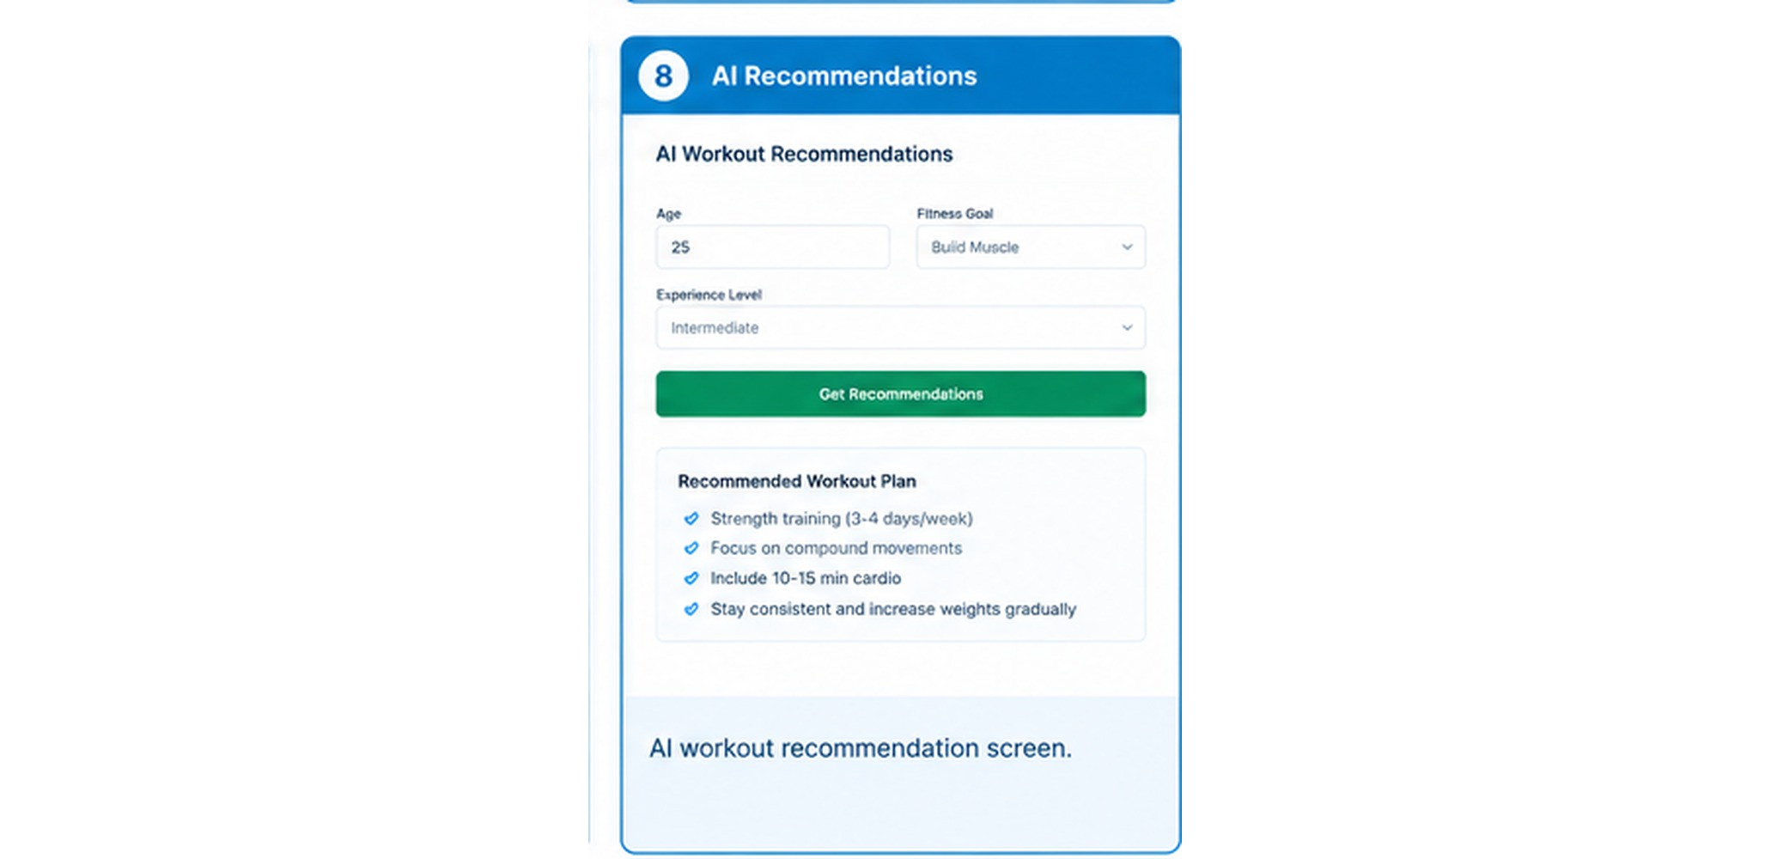

AI Fitness Insights API
Endpoint:
POST /api/ai/fitness-insights
{
"totalWorkouts": 10,
"averageDuration": 45,
"totalCaloriesBurned": 2500
}
The service is intended to return performance analysis, improvement suggestions, motivational guidance, and a progress summary.
Figure 14: AI fitness insights
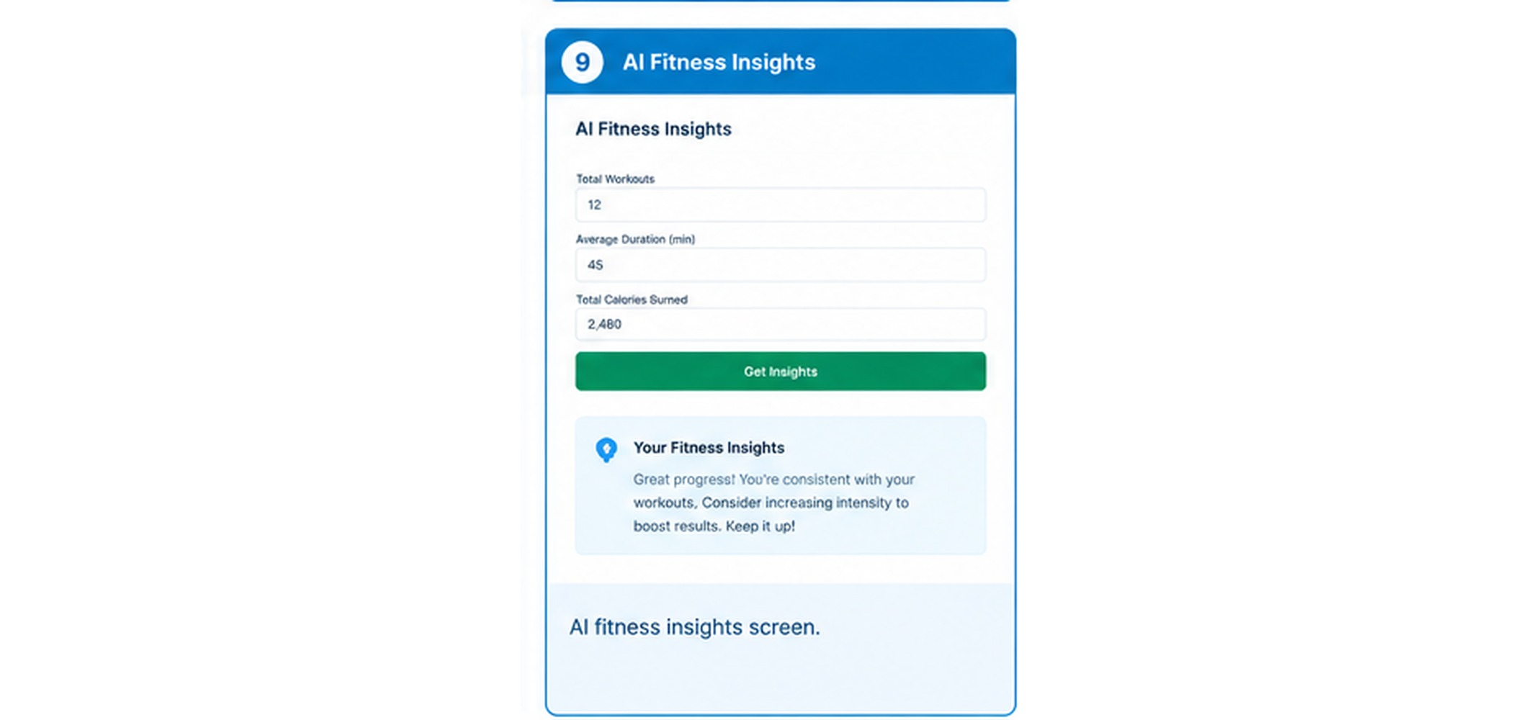

Complete API Route Reference
Method | Endpoint | Auth | Purpose
GET | /api/health | No | Health/status check
POST | /api/auth/register | No | Register user
POST | /api/auth/login | No | Login user
GET | /api/auth/profile | Yes | Get profile
PUT | /api/auth/profile | Yes | Update profile
POST | /api/workouts | Yes | Create workout
GET | /api/workouts | Yes | List/filter workouts
GET | /api/workouts/search | Yes | Search workouts
GET | /api/workouts/:id | Yes | Get workout by ID
PUT | /api/workouts/:id | Yes | Update workout
DELETE | /api/workouts/:id | Yes | Delete workout
GET | /api/dashboard | Yes | Dashboard analytics
POST | /api/ai/workout-recommendation | Yes | AI recommendation
POST | /api/ai/fitness-insights | Yes | AI fitness insights

API Testing with Thunder Client
Thunder Client is the API testing tool used for this upgraded project. It runs inside Visual Studio Code and can test the same REST endpoints consumed by the React frontend.
● 1. GET /api/health
● 2. POST /api/auth/register
● 3. POST /api/auth/login
● 4. Copy the JWT token.
● 5. GET /api/auth/profile
● 6. PUT /api/auth/profile
● 7. POST /api/workouts
● 8. GET /api/workouts and search/filter requests
● 9. GET /api/workouts/:id
● 10. PUT /api/workouts/:id
● 11. GET /api/dashboard
● 12. POST AI recommendation and insight requests
● 13. DELETE /api/workouts/:id

Authentication API Testing

Register User
POST /api/auth/register
{
"name": "John",
"email": "john@example.com",
"password": "12345678"
}

Login User
POST /api/auth/login
{
"email": "john@example.com",
"password": "12345678"
}
After login, copy the returned JWT token and use it as a Bearer token for protected requests.
Figure 15: Authentication API results

Profile API Testing

Get Profile
GET /api/auth/profile

Update Profile
PUT /api/auth/profile
{
"name": "John Alan",
"age": 25,
"heightCm": 175,
"weightKg": 70,
"fitnessGoal": "Muscle Gain",
"experience": "Intermediate"
}

Workout API Testing - Read

Get All Workouts
GET /api/workouts?page=1&limit=10

Get Workout By ID
GET /api/workouts/:id

Search
GET /api/workouts/search?q=running
Figure 16: Workout read/search

Workout API Testing - Update and Delete

Update Workout
PUT /api/workouts/:id
{
"workoutName": "Morning Running - Updated",
"duration": 40,
"caloriesBurned": 330
}

Delete Workout
DELETE /api/workouts/:id

Dashboard API Testing
GET /api/dashboard
The response should include workout totals, average duration, streak information, category counts, weekly activity, and recent workouts.

AI API Testing and Current Gemini Access Note
Both AI endpoints are implemented in the backend and route through the Gemini service. During development, the project successfully connected to MongoDB Atlas and reached the Gemini service, but the Google project returned a 403 permission error indicating that the project had been denied access.
This is an external Google AI project access/configuration issue rather than a MongoDB, Express, or route-definition failure. A successful AI screenshot should be inserted after generation access is available. Until then, a controlled 403 screenshot may be retained as a troubleshooting record.
Figure 17: AI route result

Environment Configuration and Execution
Sensitive configuration is stored in server/.env. The current application connects to MongoDB Atlas and runs the API on port 5000.
PORT=5000
MONGO_URI=mongodb+srv://<username>:<password>@<cluster>/<database>?...
JWT_SECRET=<long-random-secret>
GEMINI_API_KEY=<google-gemini-api-key>
GEMINI_MODEL=gemini-3.6-flash
CLIENT_URL=http://localhost:5173

Backend
cd <project-folder>\server
npm install
npm run dev

Frontend
cd <project-folder>\client
npm install
npm run dev
Figure 18: Execution terminals
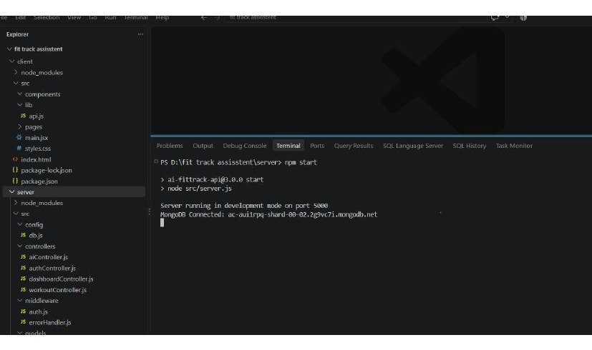

Testing Checklist
● Backend starts without errors.
● MongoDB Atlas connection succeeds.
● Health endpoint returns success.
● Registration creates a user.
● Login returns a JWT.
● Profile GET and PUT work.
● Workout create, list, search, get-by-ID, update, and delete work.
● Dashboard returns statistics.
● React frontend loads successfully.
● Protected endpoints reject requests without valid authentication.
● AI endpoints are tested with an authorized Gemini project.
● No secrets are visible in screenshots.
● Thunder Client screenshots match the documented routes.
Figure 19: Final test evidence

Error Handling and Security
The backend uses centralized error handling so route failures are returned as structured JSON rather than uncontrolled server output.
● Invalid credentials are rejected.
● Missing or invalid JWT tokens are rejected.
● Validation errors return controlled messages.
● Database failures are handled centrally.
● Not-found resources return appropriate errors.
● Gemini provider failures are logged and converted into controlled API errors.

Security Practices
● Passwords are hashed with bcryptjs.
● JWT protects authenticated resources.
● User-specific queries use the authenticated user ID.
● Secrets are stored in environment variables.
● Helmet and CORS are configured in Express.
● API keys, database passwords, and JWT secrets must not appear in screenshots or source control.

Future Enhancements and Conclusion

Future Enhancements
● Nutrition and meal tracking.
● BMI calculation.
● Wearable device integration.
● Workout reminders and scheduled notifications.
● Expanded analytics dashboards.
● Goal progress tracking.
● Additional AI coaching features.
● More granular roles and permissions.

Conclusion
AI FitTrack provides a structured full-stack solution for workout tracking and AI-assisted fitness guidance. The upgraded implementation combines React, Express, MongoDB Atlas, JWT authentication, workout CRUD, search and filters, dashboard analytics, and Gemini service integration.
The modular architecture supports maintainability and future growth. Thunder Client verifies each API independently while the React client demonstrates the same backend services in a user-facing application.
The project is ready for functional demonstration once the external Gemini project has the required generation access. The remaining authentication, workout, search, dashboard, and database functions operate independently of that external permission.
Figure 20: Final project / demonstration screen
Documentation prepared from the supplied AI FitTrack reference document and the upgraded project implementation described in this project.

Project Resource Links
Quick access to the project code, templates, demonstration, and API documentation
1. Project Code
2. Phase-Wise Template
3. Demo Video
4. API Explanation

Team Details
Team ID : SWTID-2026-9501
Team Size : 4
Team Leader : John alan paul J
Team member : Santhosh R
Team member : Sathish R
Team member : Subanraj G

